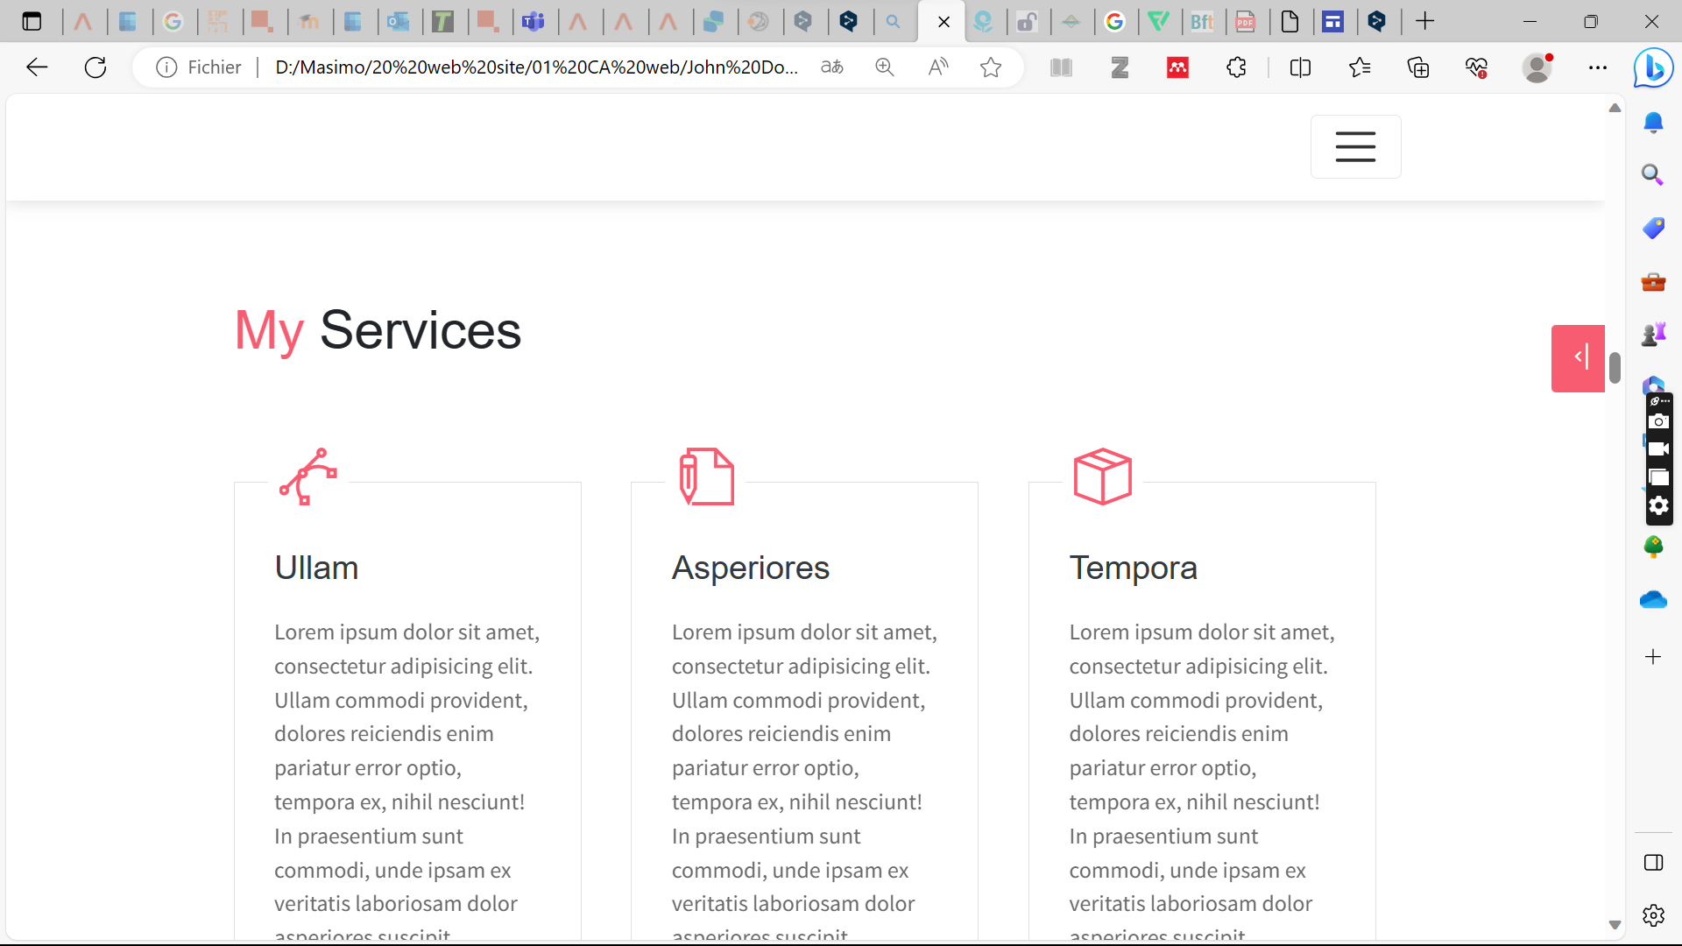

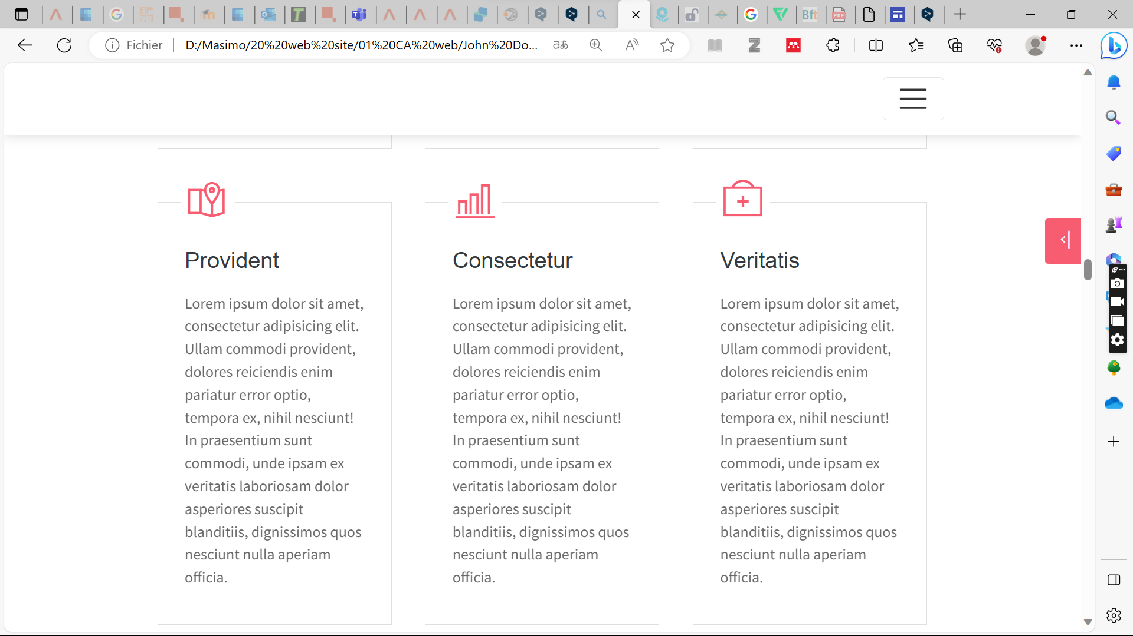

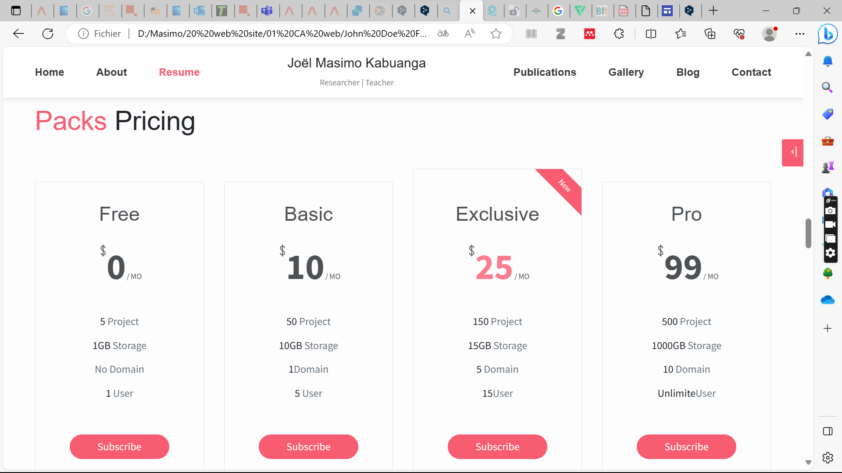

<section class="section" id="service">

<div class="container">

<h2 class="mb-5 pb-4"><span class="text-danger">My</span> Services</h2>

<div class="row">

<div class="col-md-4 col-sm-6">

<div class="card mb-5">

<div class="card-header has-icon">

<i class="ti-vector text-danger" aria-hidden="true"></i>

</div>

<div class="card-body px-4 py-3">

<h5 class="mb-3 card-title text-dark">Ullam</h5>

<P class="subtitle">Lorem ipsum dolor sit amet, consectetur adipisicing elit. Ullam commodi provident, dolores reiciendis enim pariatur error optio, tempora ex, nihil nesciunt! In praesentium sunt commodi, unde ipsam ex veritatis laboriosam dolor asperiores suscipit blanditiis, dignissimos quos nesciunt nulla aperiam officia.</P>

</div>

</div>

</div>

<div class="col-md-4 col-sm-6">

<div class="card mb-5">

<div class="card-header has-icon">

<i class="ti-write text-danger" aria-hidden="true"></i>

</div>

<div class="card-body px-4 py-3">

<h5 class="mb-3 card-title text-dark">Asperiores</h5>

<P class="subtitle">Lorem ipsum dolor sit amet, consectetur adipisicing elit. Ullam commodi provident, dolores reiciendis enim pariatur error optio, tempora ex, nihil nesciunt! In praesentium sunt commodi, unde ipsam ex veritatis laboriosam dolor asperiores suscipit blanditiis, dignissimos quos nesciunt nulla aperiam officia.</P>

</div>

</div>

</div>

<div class="col-md-4 col-sm-6">

<div class="card mb-5">

<div class="card-header has-icon">

<i class="ti-package text-danger" aria-hidden="true"></i>

</div>

<div class="card-body px-4 py-3">

<h5 class="mb-3 card-title text-dark">Tempora</h5>

<P class="subtitle">Lorem ipsum dolor sit amet, consectetur adipisicing elit. Ullam commodi provident, dolores reiciendis enim pariatur error optio, tempora ex, nihil nesciunt! In praesentium sunt commodi, unde ipsam ex veritatis laboriosam dolor asperiores suscipit blanditiis, dignissimos quos nesciunt nulla aperiam officia.</P>

</div>

</div>

</div>

<div class="col-md-4 col-sm-6">

<div class="card mb-5">

<div class="card-header has-icon">

<i class="ti-map-alt text-danger" aria-hidden="true"></i>

</div>

<div class="card-body px-4 py-3">

<h5 class="mb-3 card-title text-dark">Provident</h5>

<P class="subtitle">Lorem ipsum dolor sit amet, consectetur adipisicing elit. Ullam commodi provident, dolores reiciendis enim pariatur error optio, tempora ex, nihil nesciunt! In praesentium sunt commodi, unde ipsam ex veritatis laboriosam dolor asperiores suscipit blanditiis, dignissimos quos nesciunt nulla aperiam officia.</P>

</div>

</div>

</div>

<div class="col-md-4 col-sm-6">

<div class="card mb-5">

<div class="card-header has-icon">

<i class="ti-bar-chart text-danger" aria-hidden="true"></i>

</div>

<div class="card-body px-4 py-3">

<h5 class="mb-3 card-title text-dark">Consectetur</h5>

<P class="subtitle">Lorem ipsum dolor sit amet, consectetur adipisicing elit. Ullam commodi provident, dolores reiciendis enim pariatur error optio, tempora ex, nihil nesciunt! In praesentium sunt commodi, unde ipsam ex veritatis laboriosam dolor asperiores suscipit blanditiis, dignissimos quos nesciunt nulla aperiam officia.</P>

</div>

</div>

</div>

<div class="col-md-4 col-sm-6">

<div class="card mb-5">

<div class="card-header has-icon">

<i class="ti-support text-danger" aria-hidden="true"></i>

</div>

<div class="card-body px-4 py-3">

<h5 class="mb-3 card-title text-dark">Veritatis</h5>

<P class="subtitle">Lorem ipsum dolor sit amet, consectetur adipisicing elit. Ullam commodi provident, dolores reiciendis enim pariatur error optio, tempora ex, nihil nesciunt! In praesentium sunt commodi, unde ipsam ex veritatis laboriosam dolor asperiores suscipit blanditiis, dignissimos quos nesciunt nulla aperiam officia.</P>

</div>

</div>

</div>

</div>

</div>

</section>

<section class="section bg-custom-gray" id="price">

<div class="container">

<h1 class="mb-5"><span class="text-danger">Packs</span> Pricing</h1>

<div class="row align-items-center">

<div class="col-md-6 col-lg-3">

<div class="price-card text-center mb-4">

<h3 class="price-card-title">Free</h3>

<div class="price-card-cost">

<sup class="ti-money"></sup>

<span class="num">0</span>

<span class="date">MO</span>

</div>

<ul class="list">

<li class="list-item">5 <span class="text-muted">Project</span></li>

<li class="list-item">1GB <span class="text-muted">Storage</span></li>

<li class="list-item"><span class="text-muted">No Domain</span></li>

<li class="list-item">1 <span class="text-muted">User</span></li>

</ul>

<button class="btn btn-primary btn-rounded w-lg">Subscribe</button>

</div>

</div>

<div class="col-md-6 col-lg-3">

<div class="price-card text-center mb-4">

<h3 class="price-card-title">Basic</h3>

<div class="price-card-cost">

<sup class="ti-money"></sup>

<span class="num">10</span>

<span class="date">MO</span>

</div>

<ul class="list">

<li class="list-item">50 <span class="text-muted">Project</span></li>

<li class="list-item">10GB <span class="text-muted">Storage</span></li>

<li class="list-item">1<span class="text-muted">Domain</span></li>

<li class="list-item">5 <span class="text-muted">User</span></li>

</ul>

<button class="btn btn-primary btn-rounded w-lg">Subscribe</button>

</div>

</div>

<div class="col-md-6 col-lg-3">

<div class="price-card text-center price-card-requried mb-4">

<h3 class="price-card-title">Exclusive</h3>

<div class="price-card-cost">

<sup class="ti-money"></sup>

<span class="num">25</span>

<span class="date">MO</span>

</div>

<ul class="list">

<li class="list-item">150 <span class="text-muted">Project</span></li>

<li class="list-item">15GB <span class="text-muted">Storage</span></li>

<li class="list-item">5<span class="text-muted"> Domain</span></li>

<li class="list-item">15<span class="text-muted">User</span></li>

</ul>

<button class="btn btn-primary btn-rounded w-lg">Subscribe</button>

</div>

</div>

<div class="col-md-6 col-lg-3">

<div class="price-card text-center mb-4">

<h3 class="price-card-title">Pro</h3>

<div class="price-card-cost">

<sup class="ti-money"></sup>

<span class="num">99</span>

<span class="date">MO</span>

</div>

<ul class="list">

<li class="list-item">500 <span class="text-muted">Project</span></li>

<li class="list-item">1000GB <span class="text-muted">Storage</span></li>

<li class="list-item">10<span class="text-muted"> Domain</span></li>

<li class="list-item">Unlimite<span class="text-muted">User</span></li>

</ul>

<button class="btn btn-primary btn-rounded w-lg">Subscribe</button>

</div>

</div>

</div>

</div>

</section>

<section class="section bg-dark py-5">

<div class="container text-center">

<h2 class="text-light mb-5 font-weight-normal">I Am Available For FreeLance</h2>

<button class="btn bg-primary w-lg" >Hire me</button>

</div>

</section>